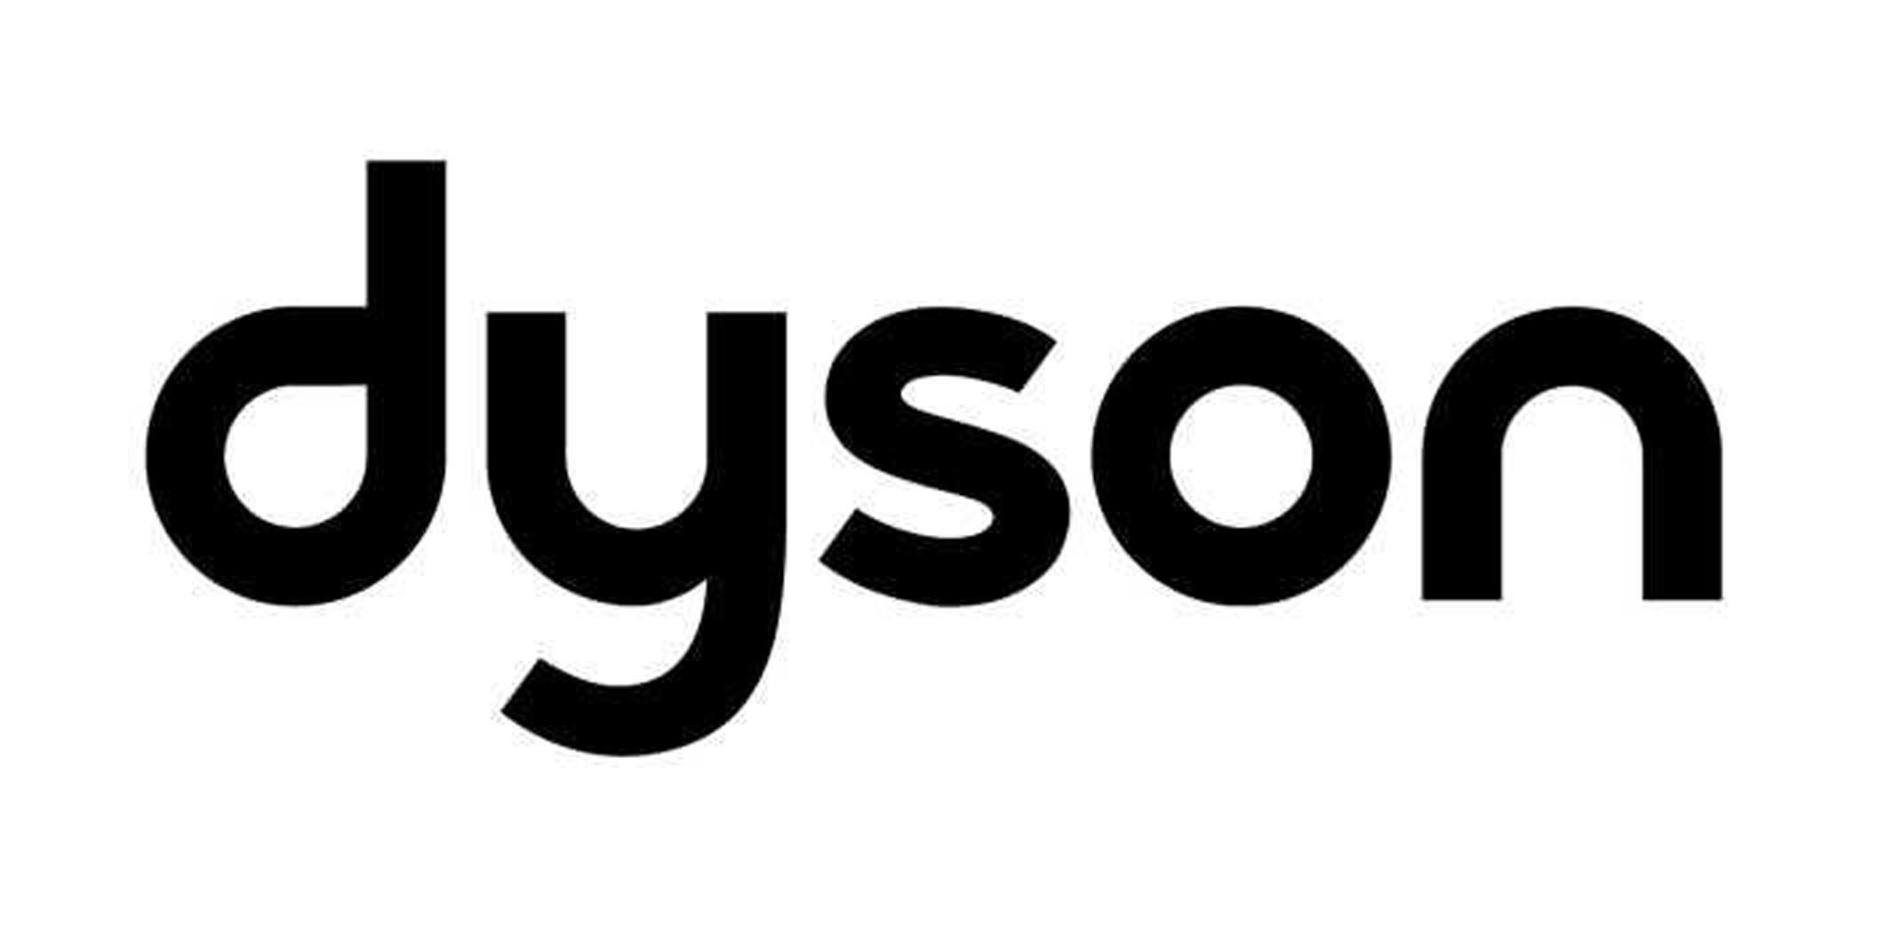

MEDIA RELEASE

For immediate release

SMALL SIZE. BIG PERFORMANCE.
Dyson concentrates technology with powerful results.

There’s a demand for small-sized technology – just think about the can’t-live-without accessories that have made their way into our lives in recent years: mobile phones, mp3 players, computers and digital cameras, to name just a few.

This trend also continues when it comes to housing, and home wares. And, with the latest forecast from the Australian Bureau of Statistics projecting lone and no children households being the fastest growing segments over the next 20 years, it’s a trend that looks set to continue.

New from Dyson, the DC22 Compact has been designed specifically to suit these smaller lifestyle requirements. Dyson technology has been concentrated to develop this lightweight, compact cleaner that is one-third smaller than other Dyson vacuum cleaners – without losing any of the powerful cleaning performance of the full-sized version.

DC22 uses Dyson’s most advanced cyclone technology. Instead of using a bag or filter to trap dirt and dust, Dyson technology spins the dirt and dust out of airflow – removing even the tiniest particles - resulting in a vacuum cleaner that doesn’t lose suction, giving a superior clean, from the first room right through to the last.

Easy steer motorhead

The powerful, independently driven motorised head utilises Dyson’s ball-like technology so it is easy-to-steer around household obstacles. The brushes agitate the carpet to remove deep down dirt, but can be easily turned off with fingertip controls to move between carpets and hard floors. These controls can also turn the vacuum cleaner on/off so the user doesn’t need to bend down.

Telescope wrap

There’s nothing worse than unwieldy wands when you’re trying to move and store your vacuum cleaner. DC22 has Dyson’s unique wand and hose wrap system that fits neatly around the machine, making it easy to carry and store.

Hygiene

One-touch bin emptying makes disposing of dirt quick, easy and hygienic. It is also accepted by the National Asthma Council of Australia as a Sensitive Choice for people with asthma and allergies.

Accessories

Dyson-designed accessories make cleaning quicker and more effective: a hard floor tool to protect delicate surfaces, upholstery tool to clean couches and curtains, plus a combi-crevice tool for hard-to-reach places.

Dyson’s little book of cleaning tips

Finally, whilst cleaning is our life, we know it’s not something you spend too much time thinking about. So, to go along with our latest little machine, we thought we’d share a few top tips from our little book of cleaning:

Bed-bugs-bite: snug as a bug in bed is closer to the truth than you might think. The warm, cozy conditions make the perfect breeding ground for dust mites and as you shed skin-cells on your bed clothes you’re providing lots of food for them to thrive on too. Vacuum you mattress regularly with a specially designed tool – it’ll get rid of the nasties.

Dust-away: save time and do a better job cleaning the house by dusting at the same time as the vacuum. Dyson’s soft dusting brush attach attached to your vacuum cleaner, gently wipes down surfaces and simply sucks the dust and dirt away.

Crumby keyboard: your computer keyboard may not be as harmless as it looks. Did you know they can harbour as much bacteria as a toilet seat? Use a soft dusting brush attached to your cleaner, or a Dyson DC16 handheld to remove dust and crumbs. To disinfect spray a light mixture of eucalyptus oil and water onto the keyboard and wipe gently (make sure the power is off).

Dyson DC22 Compact is available in Australia from 1 April 2009 for RRP$899.

- ENDS -

For further information please contact Erica Galea on 02 9540 0407/ 0411 217 435 or via email ericag@dyson.com.au

Notes to editor:
- James Dyson spent 10 years and made 5,127 prototypes whilst developing and perfecting a vacuum cleaner that would not lose suction; it remains the only vacuum cleaner able to make this claim.
- One-third of Dyson employees (500 worldwide) are engineers and scientists working to develop products that work significantly better than those they replace.
- Dyson is the leading vacuum cleaner brand in Australia and New Zealand.
- Dyson has a range of vacuum cleaner, handhelds and cleaning accessories designed to suit different lifestyle requirements. The range at www.dyson.com.au.
- Dyson offers a 7-day customer care helpline – 1800 239 766.
- Dyson have been a supporting partner of the Asthma Foundations of Australia for 10 years. Additional information on the Asthma Foundations of Australia visit www.asthmaaustralia.org.au or call 1800 645 130.
- All Dyson vacuum cleaners have been exclusively accepted into the National Asthma Council Sensitive Choice program. For more information on the program visit www.sensitivechoice.com.au.

